Flutter Installation Documentation

**Step 1:** Open Command Prompt

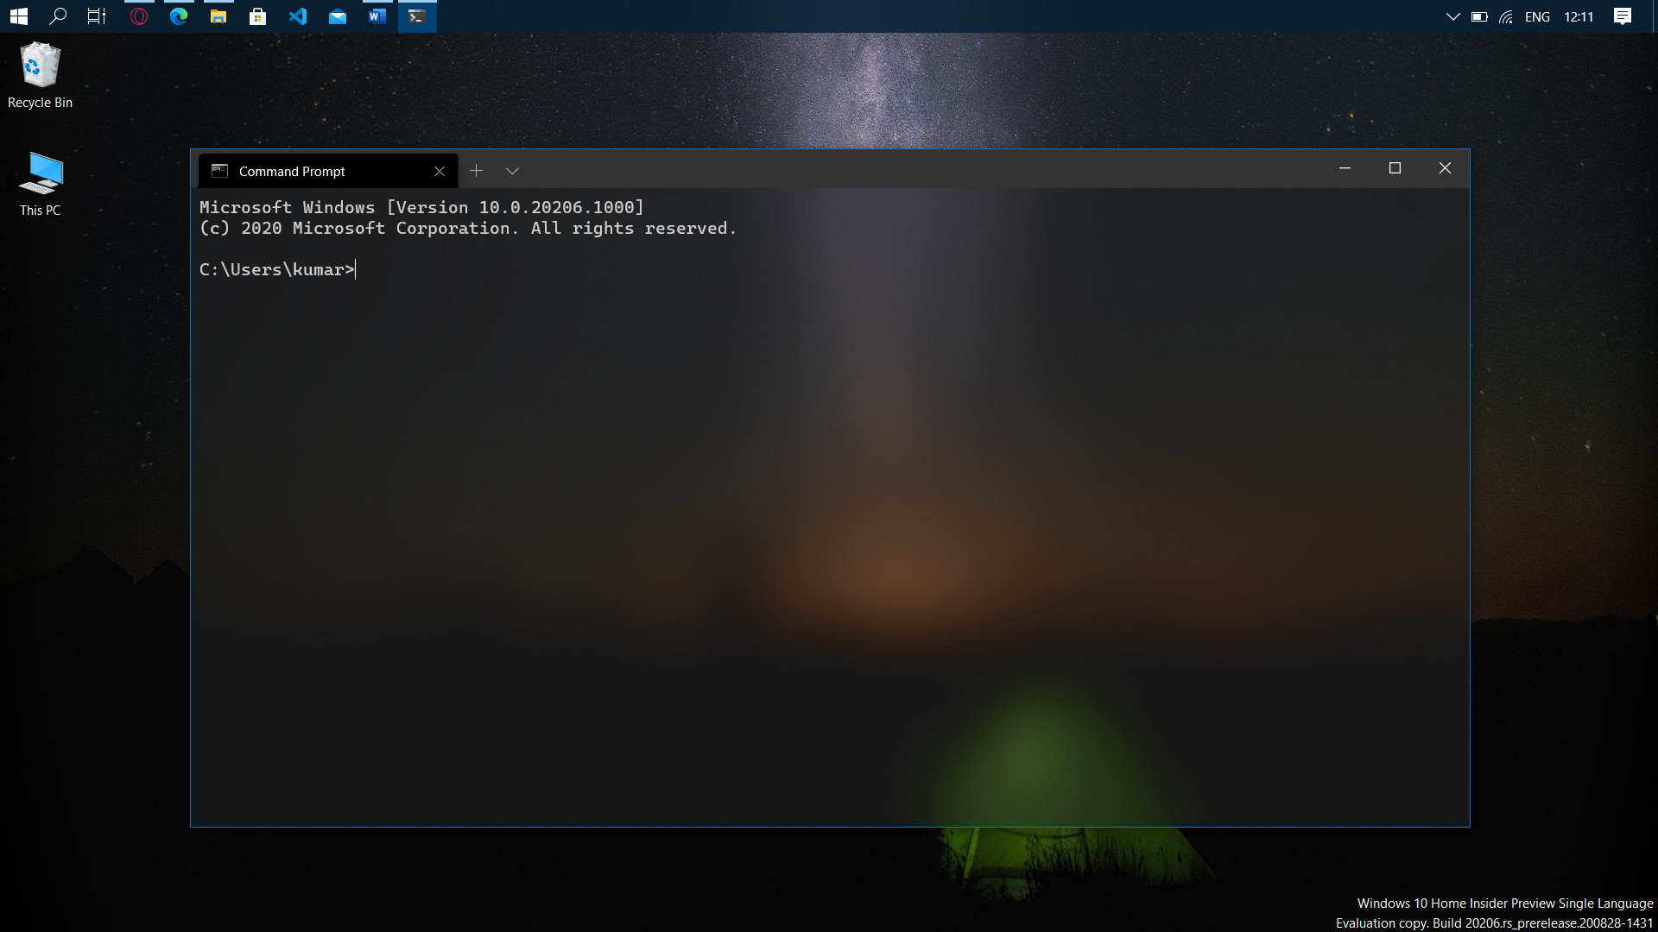

**Step 2:** cd to the desired installation location for the Flutter SDK

(for example, C:\src\flutter).

**Warning:** Do not install Flutter in a directory like C:\Program Files\ that requires elevated privileges.

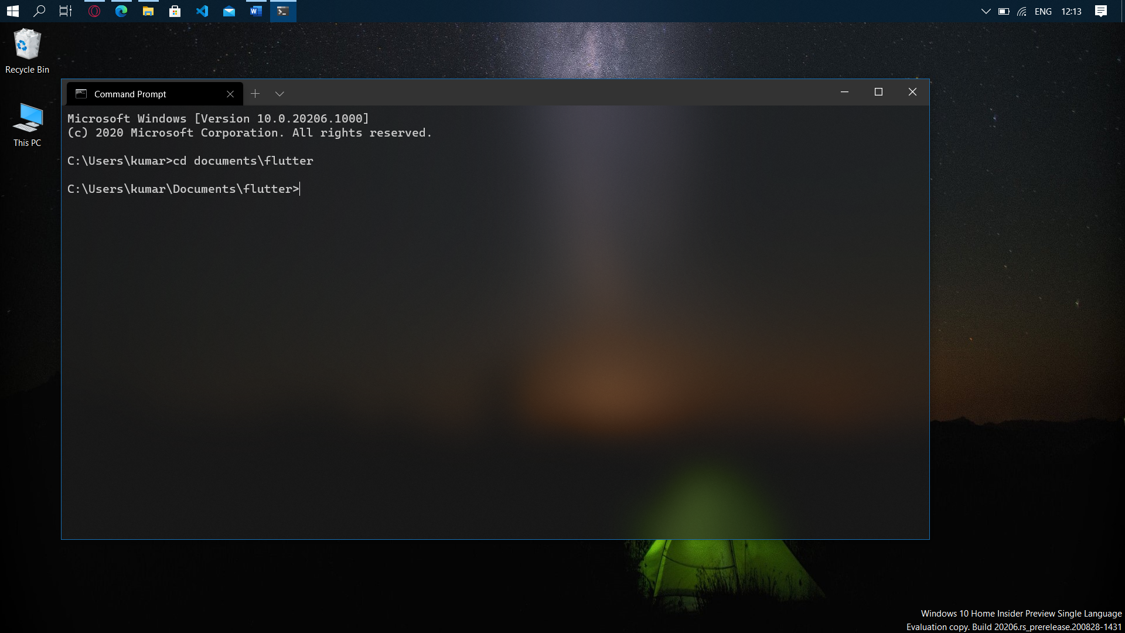

**Step 3: (Make sure git is installed)** Run the following command –

git clone https://github.com/flutter/flutter.git -b stable

**Step 4:** Type ‘env’ in windows search bar and open “Edit environment variables for your account” 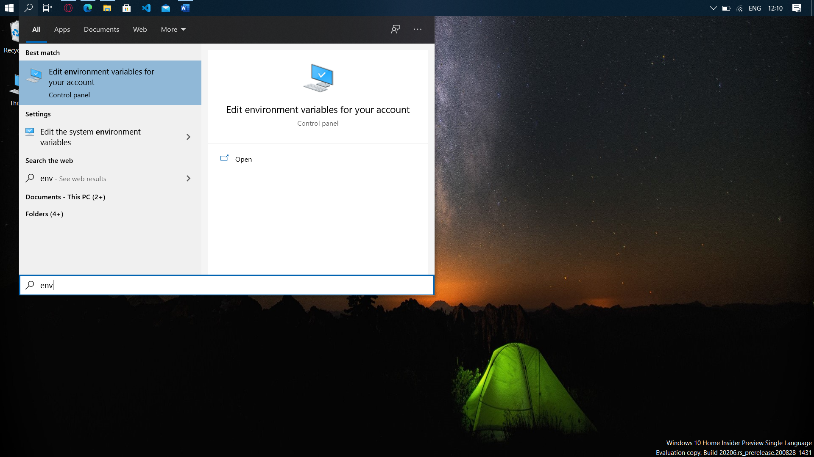

**Step 5:** Select ‘Path’ and click on ‘Edit’

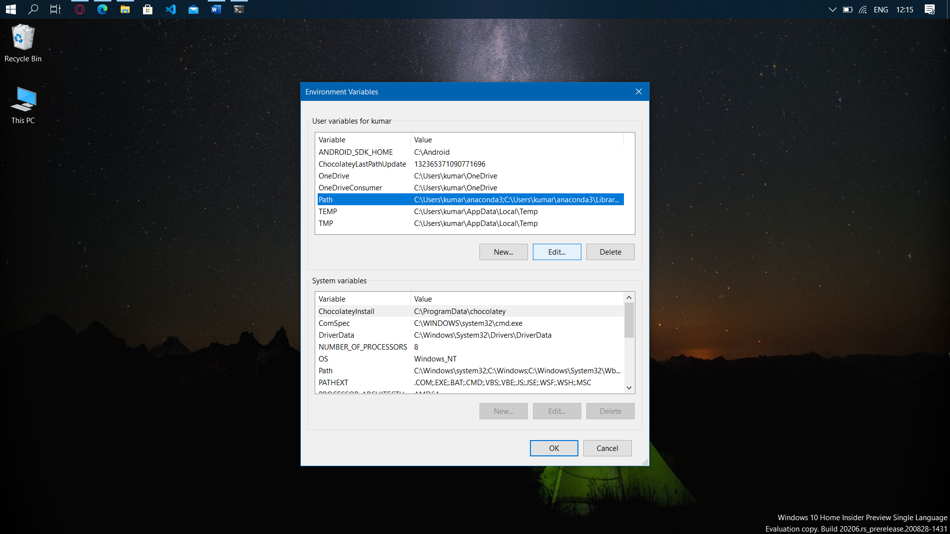

**Step 6:** Click on new and type the full path to Flutter SDK with flutter\bin as its value and press ok.

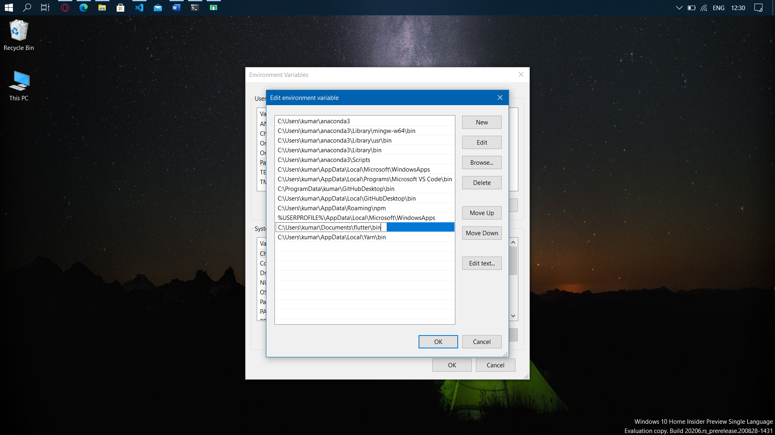

**Step 7:** Again, open command prompt and run – flutter doctor

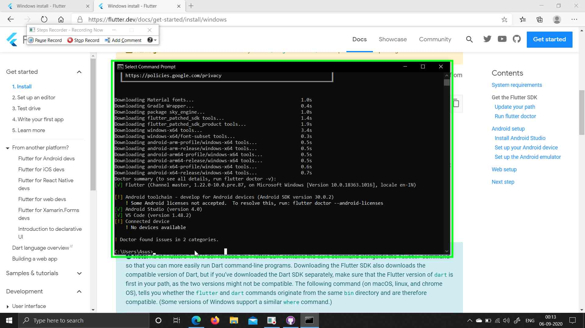

**Step 8:** Run – flutter –android-licenses and agree to all the licenses by entering ‘y’

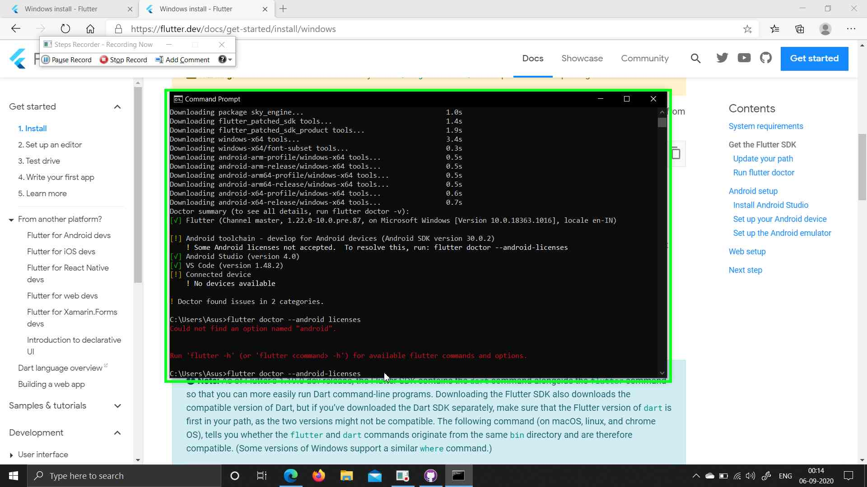

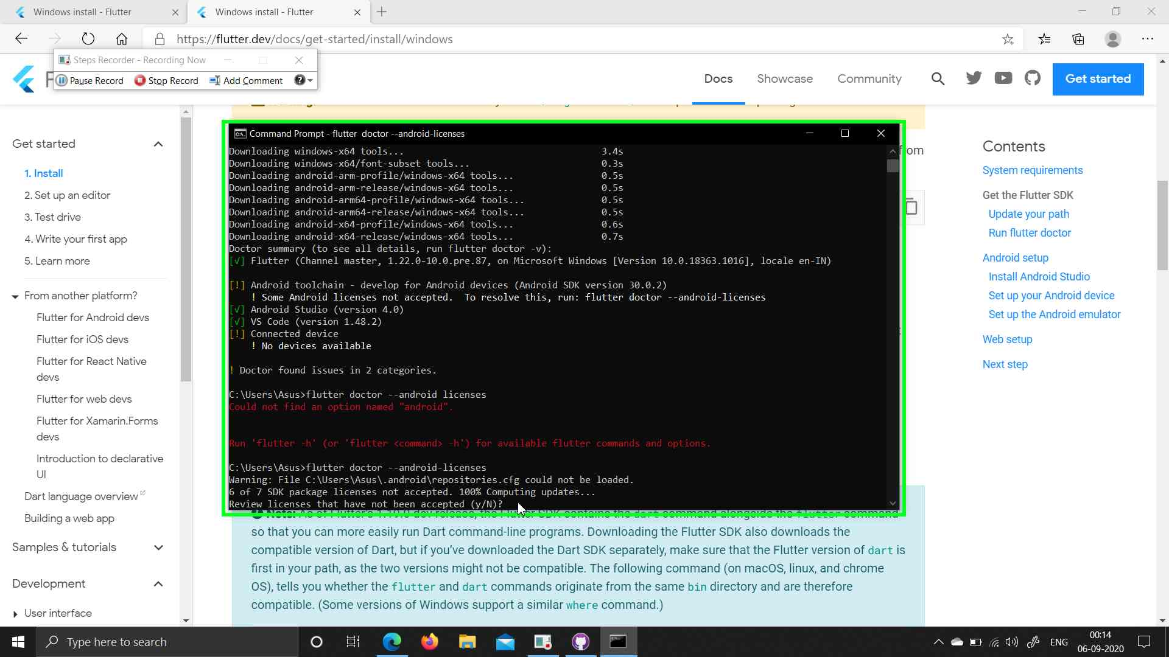

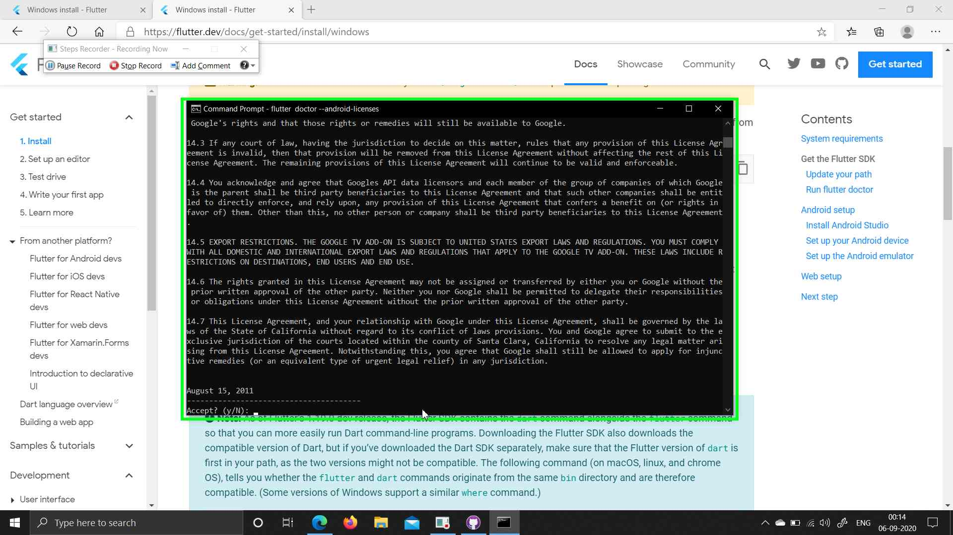

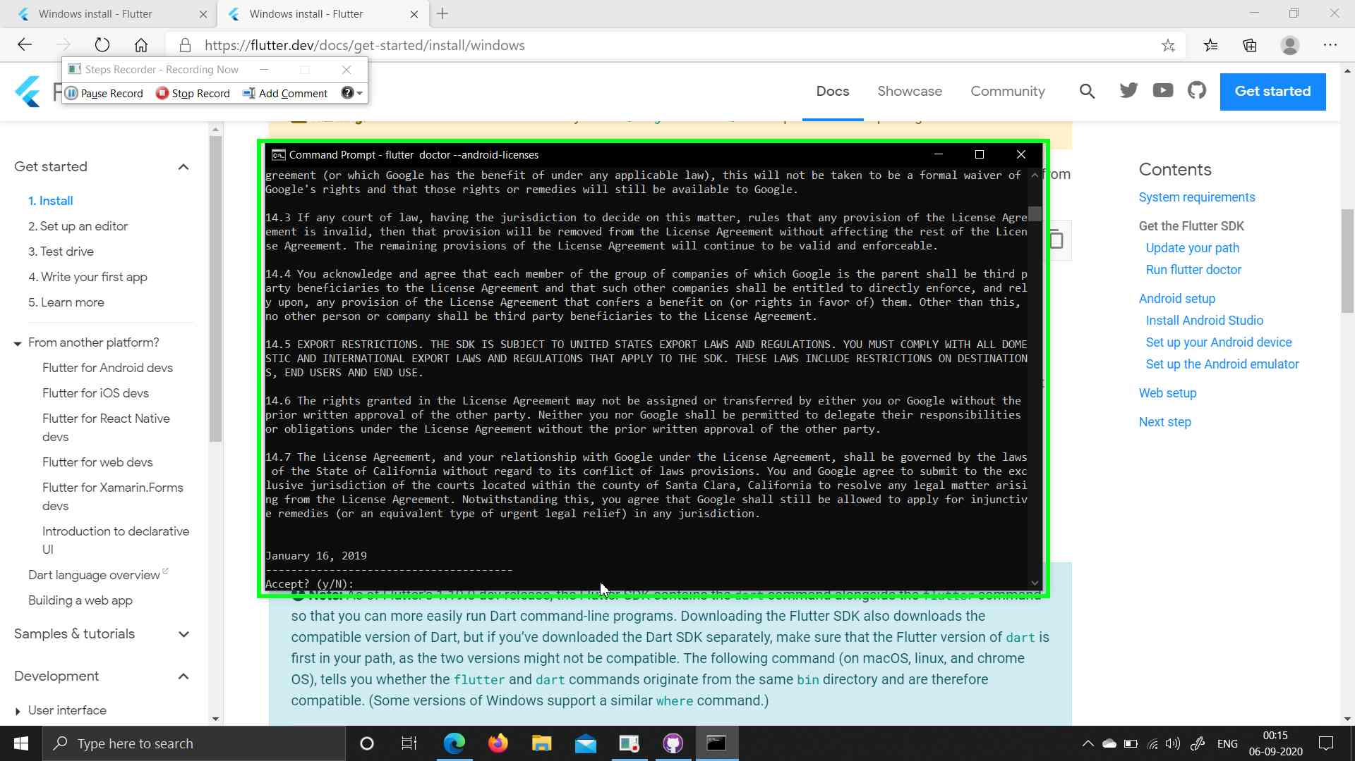

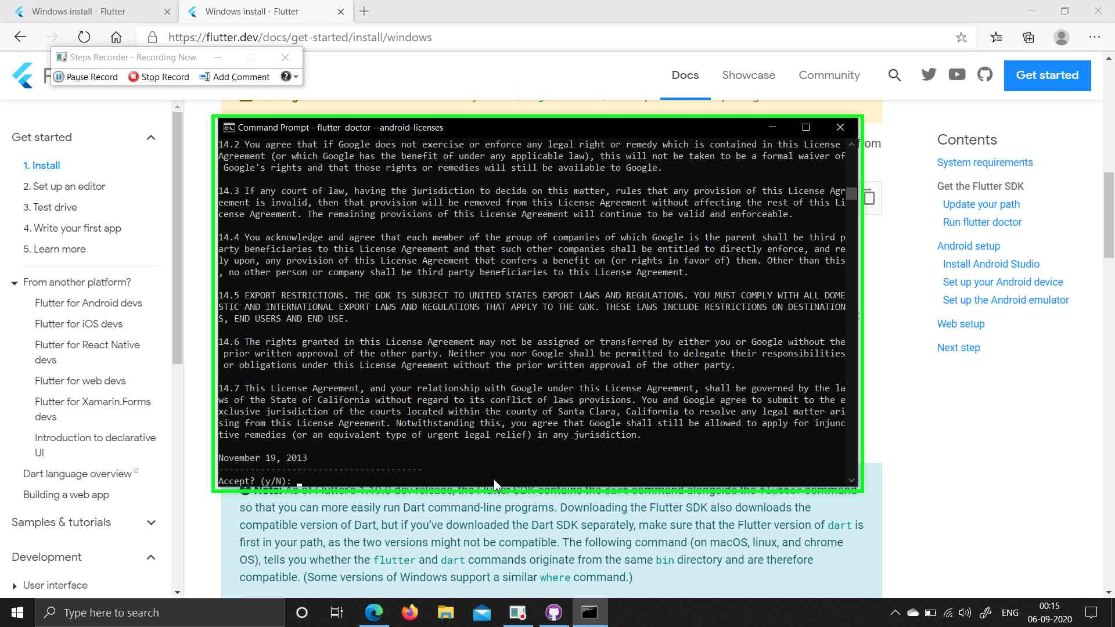

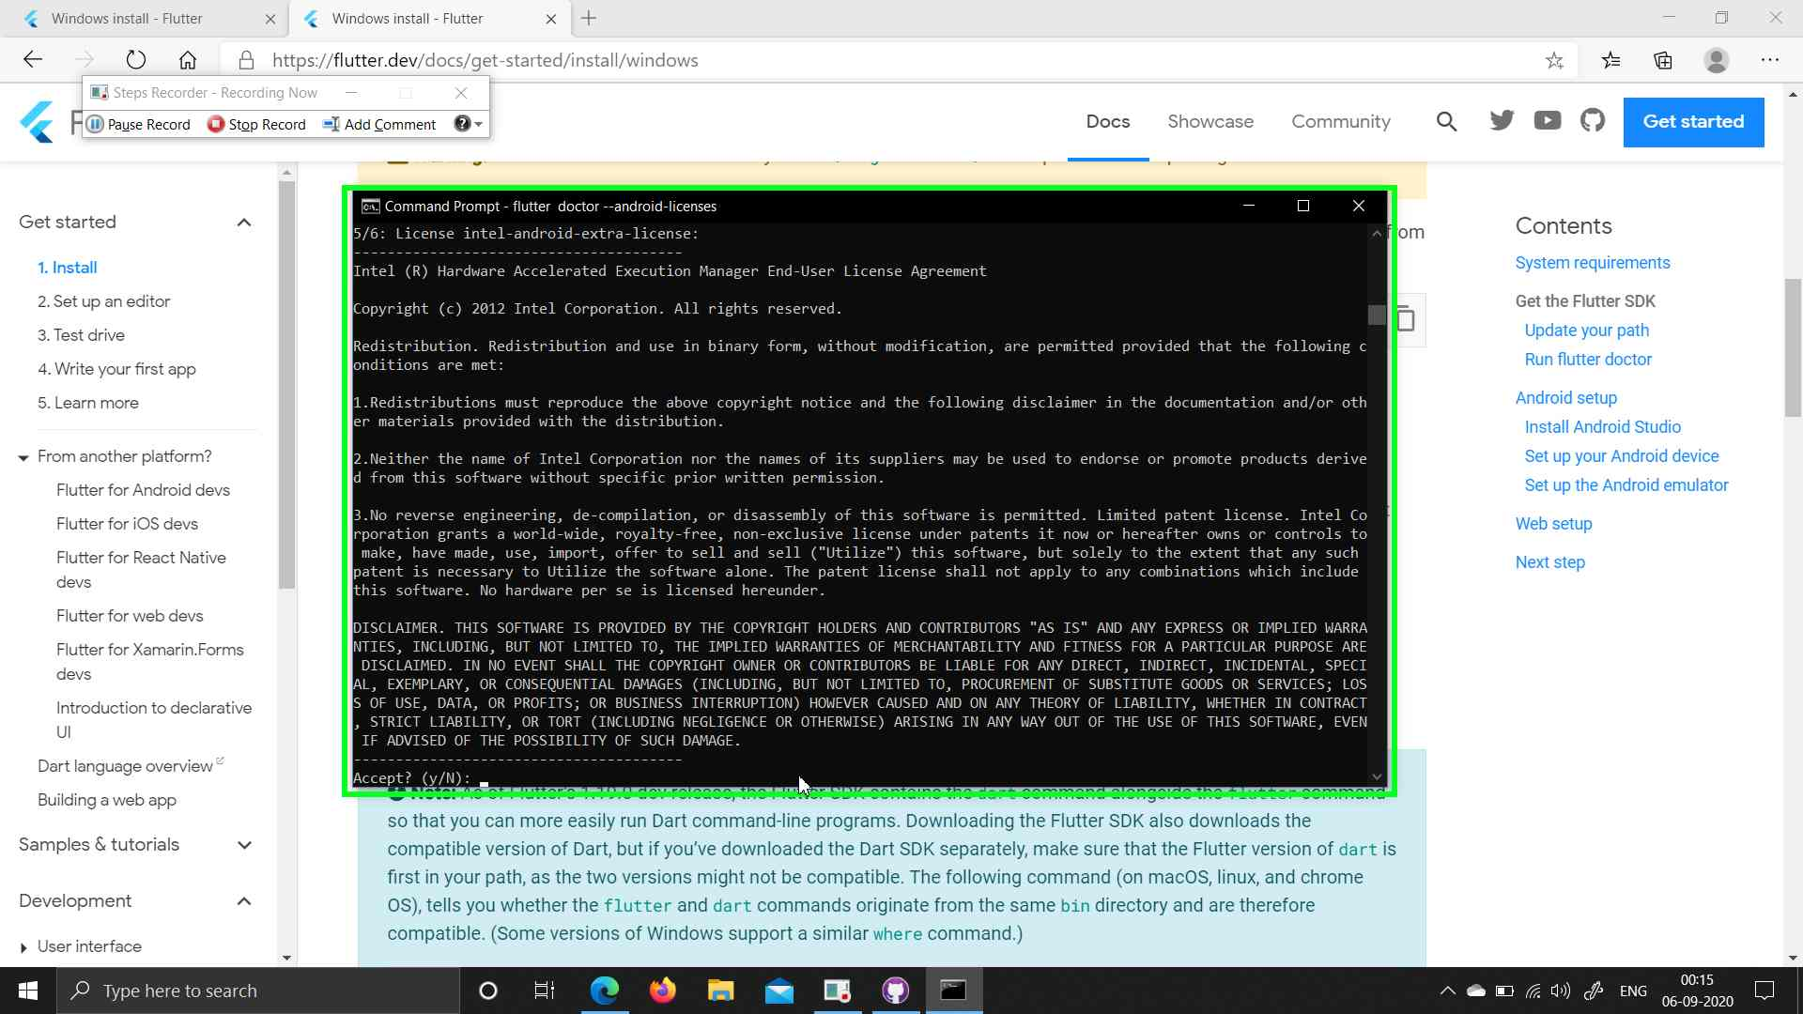

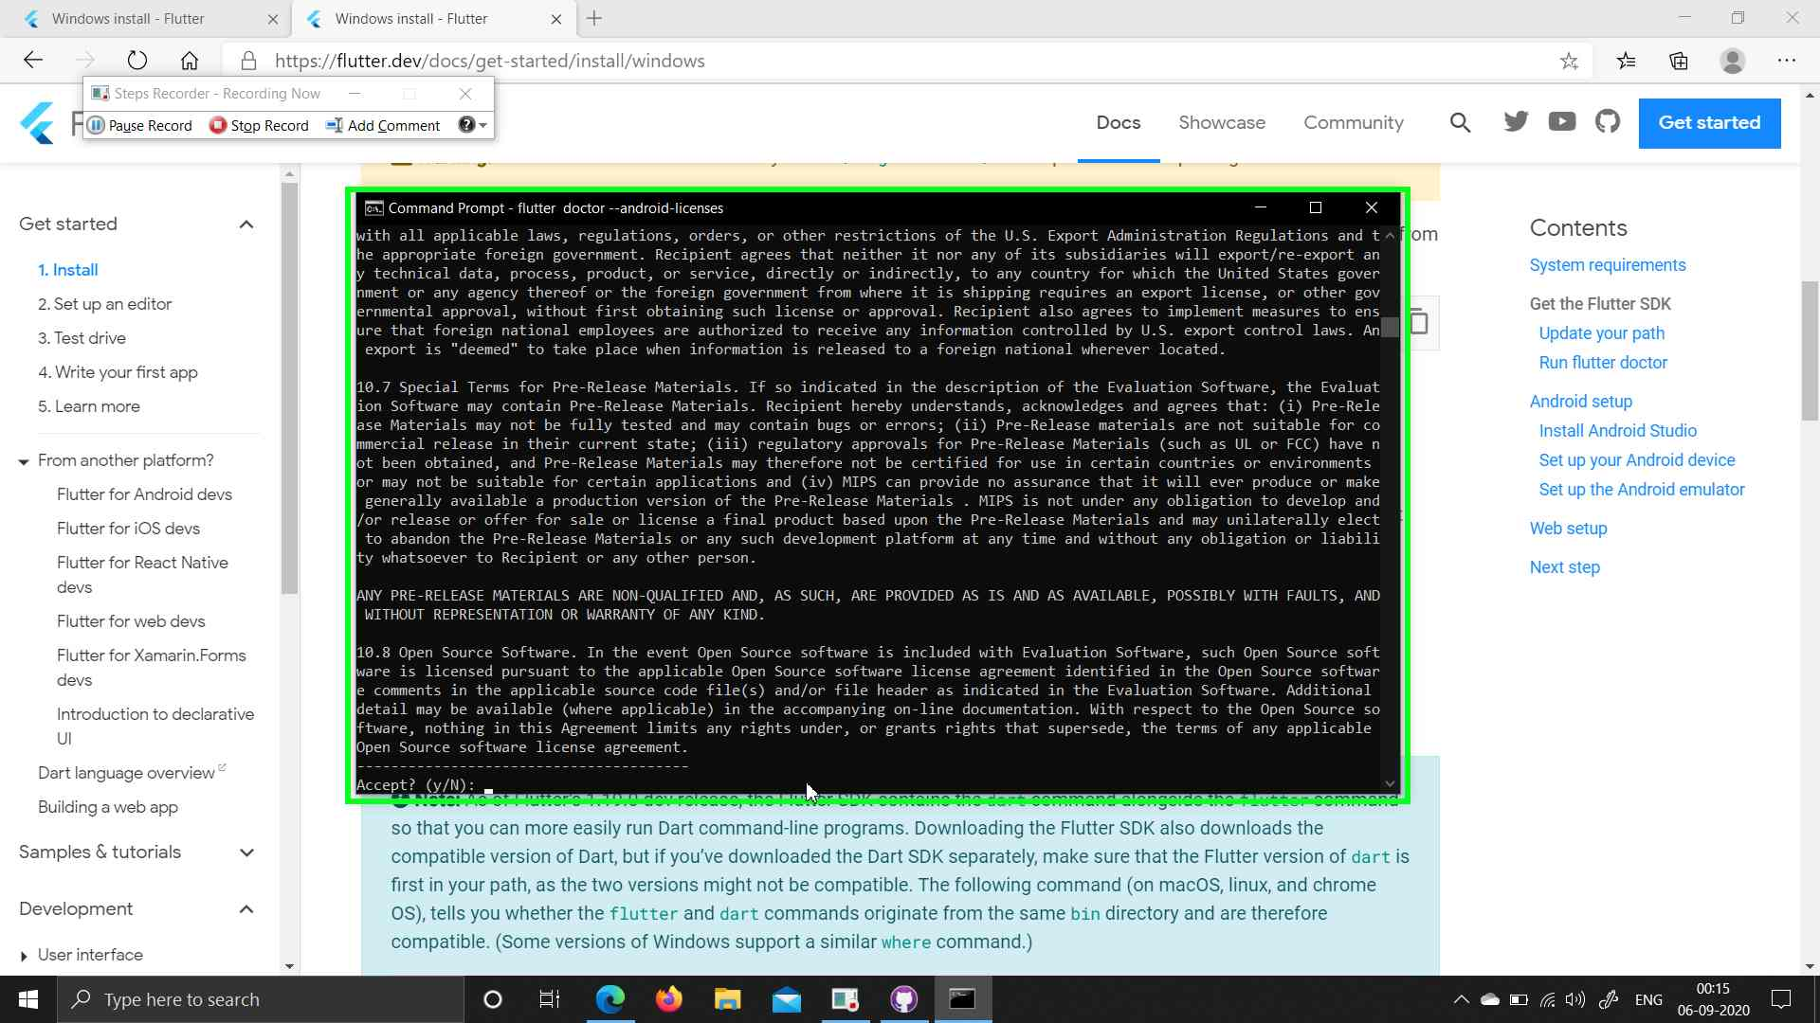

**Step 9:** Run – ‘flutter doctor’ again

